- When was the Republican Party founded?

- What does the Republican Party stand for?

- What is the symbol of the Republican Party?

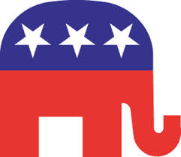
- What is a benefit and drawback of having a major political party?

- When was the Democratic Party founded?

- What does the Democratic Party Stand for?

- What is the symbol of the Democratic Party?

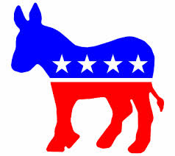
- What is a benefit and drawback of having a major political party?

- What is the definition of a “Third Party”?

- What are some examples of third parties in the United States?

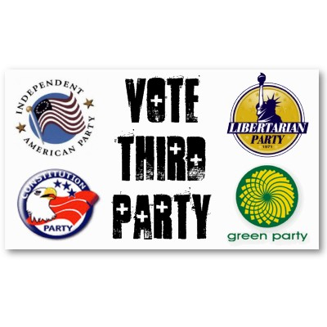
- Should Third Parties be allowed to run in Presidential elections?

Third Parties
A third party is any and all political parties in the United States other than one of the two major parties (Republican Party and Democratic Party). The term can also refer to independent politicians not affiliated with any party.
Some Third Parties include:
Libertarian Party- Libertarians believe the federal government should play a minimal role in the day-to-day affairs of the people. They believe that the only appropriate role of government is to protect the citizens from acts of physical force or fraud. A libertarian-style government would therefore limit itself to a police, court, prison system and military.
Constitution Party- The Constitution Party favors a government based a strict interpretation of the Constitution and the principals expressed in it by the Founding Fathers. They support a government limited in scope, structure and power of regulation over the people. Under this goal, the Constitution Party favors a return of most governmental powers to the states, communities and the people.
Green Party- The Green Party is devoted to smaller, community-based economies, gender equality, global sustainability (freeing the Earth of pollution), nonviolence and social justice.
Since 1877, there have been 31 U.S. Senators, 111 U.S. Representatives, and 22 governors that were not affiliated with a major political party. However, third parties do play an important role in national politics. Third parties usually organize and mobilize around a single issue or position, putting pressure on candidates from major political parties to address these issues.
Although it is unlikely that a third party candidate will ever garner a plurality of the vote, they can influence the election by taking votes away from a major party candidate. This was at issue during the 2000 election when Green Party presidential candidate Ralph Nader took votes away from Democrat Al Gore, a situation that some felt contributed to the victory of Republican George W. Bush.
Democratic Party
Are you a Democrat or a Republican? If you can answer that question, you're ahead of the game. For many people, political parties are a puzzle. The dictionary defines them as groups of people "who control or seek to control a government." So much for music and dancing.
The U.S. Constitution doesn't even mention political parties. President George Washington warned about "the danger of parties." But even then, our leaders didn't always agree. In the 1790s, a quarrel broke out between Thomas Jefferson and Alexander Hamilton over how much power to grant the federal government. The argument split their followers into two separate groups - the beginning of U.S. political parties.
The argument still forms the underlying dispute between our two main political parties: the Democrats and the Republicans. What does each group stand for?
The Party of the People
The Democratic Party is the oldest existing political party in the U.S. Some scholars say that it began when Jefferson founded the Democratic-Republicans in 1792. Jefferson opposed a strong central government.
The party later split. Some scholars say that the Democrat Party grew from a branch headed by Andrew Jackson. Jackson, elected President in 1828, believed in a strict interpretation of the Constitution and a limitation of the government's powers.
Today's Democratic Party takes a different stand. Democrats are sometimes referred to as "the Party of the People," attracting immigrants, blue-collar workers, women, and minorities. Democrats tend to take a more liberal stand (progressive or willing to change) on important issues. They believe that the federal government should take a more active role in people's lives, particularly those who are in need. Democrats support believe in having a sense of community and social responsibility.
One example is Franklin D. Roosevelt's presidency (1933–1945). To pull the U.S. out of an economic depression, Roosevelt started a many government programs to create jobs.
The symbol of the Democratic party is a donkey and are associated with the color blue on political maps.
Republican Party
Are you a Democrat or a Republican? If you can answer that question, you're ahead of the game. For many people, political parties are a puzzle. The dictionary defines them as groups of people "who control or seek to control a government." So much for music and dancing.
The U.S. Constitution doesn't even mention political parties. President George Washington warned about "the danger of parties." But even then, our leaders didn't always agree. In the 1790s, a quarrel broke out between Thomas Jefferson and Alexander Hamilton over how much power to grant the federal government. The argument split their followers into two separate groups - the beginning of U.S. political parties.
The argument still forms the underlying dispute between our two main political parties: the Democrats and the Republicans. What does each group stand for?
The Grand Old Party
The Republican Party was formed in 1854, when a man named Alvan E. Bovay brought together anti-slavery leaders. These leaders opposed the Kansas-Nebraska Act, which would permit slavery in these new territories if the people voted for it.
The party's candidate lost in 1856. The Republicans realized they needed more than one issue to win. In 1860, they still opposed slavery in the territories, but also called for a transcontinental railroad and free land to settlers. The candidate that year, Abraham Lincoln, won.
What do Republicans stand for today? In general, Republicans tend to take a more conservative stand (having traditional values and less emphasis on change) on issues. They believe that the federal government should not play a big role in people's lives. Most Republicans favor lower taxes and less government spending on social programs. They believe in less government intervention in business and the economy.
The symbol of the Republican party is an elephant and are associated with the color red on political maps.

